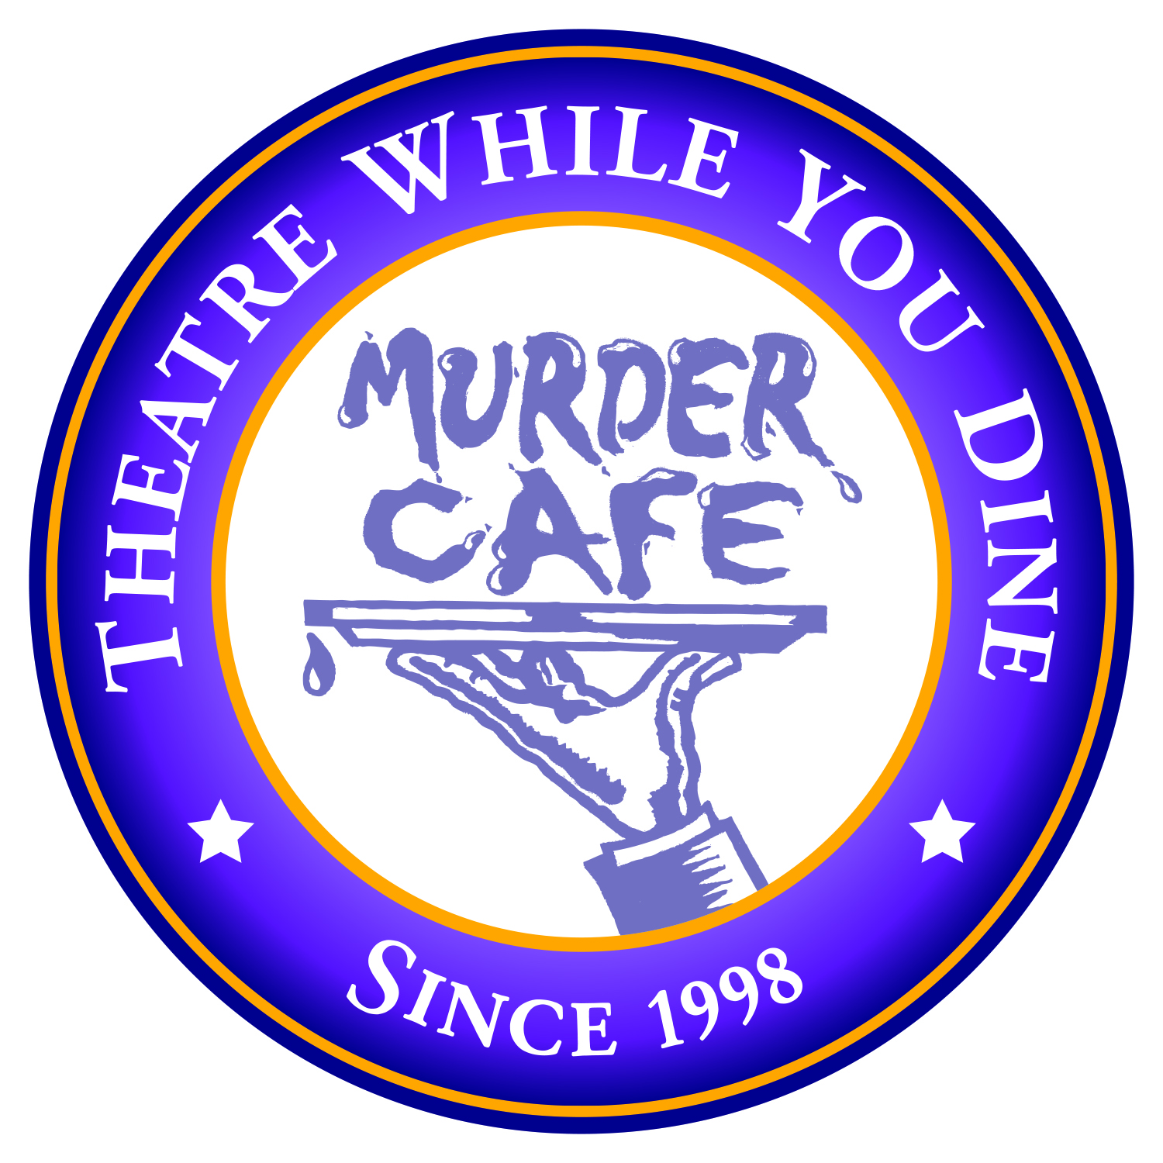
MURDER CAFE
CONTACT: Frank Marquette, Owner
TEL: 845-475-7973 EMAIL: murdercafe.ny@gmail.com
WEB: murdercafe.com

FOR IMMEDIATE RELEASE: February 10, 2020

The Beekman Arms and Murder Café present their second annual Mystery Weekend with Murder by Magic.

A Weekend of Spirited Vaudeville and Ghostly Mayhem

RHINEBECK, NY: The Beekman Arms, America’s oldest inn, and Murder Café, a locally-owned theater company in it’s 22nd year, present a three-day event, Murder by Magic: A Weekend of Spirited Vaudeville and Ghostly Mayhem. Guests will arrive on Friday, March 13th and be treated to an original murder mystery, meals and hotel accommodations until Sunday, March 15th. The historic mystery, broken into four scenes, will be performed in and around a cocktail party with hors d’oeuvres on Friday, lunch and a three-course dinner on Saturday and a sumptuous brunch on Sunday. Actors in costume will play out scenes as guests keep track of clues and engage in a game of “whodunit” on Sunday. Prizes will be available to those who correctly guess the murderer’s identity.

The festivities on Friday night will include the first scene of the murder mystery and a Speakeasy themed party. Miss Maybell and the Jazz Age Artistes, a New York City based band, will provide live music from the 1920s.

Murder Café owner and operator, Frank Marquette, summaries the mystery as follows, “The year is 1927 and veteran entertainer Phineas Phibes is emceeing the Masters of Magic and Merriment Vaudeville Show. See the world’s master magician, major medium, charming clown, kiddie crooner and top thespian; they’ll astound you with their amazing acts. Beware, The Great Merlini, the evening’s headliner, is murdered by one of his own tricks – or was he? Whodunit and who will bring Merlini back from the spirit world so he can solve the mystery of his own death?”

Weekend rates for Murder at the Inn start at $999 per couple and include tax and gratuities, two night’s luxury accommodations, gourmet meals and access to historic Rhinebeck. For information and reservations call 845-876-1766 ext. 384.

Photos and interviews are available upon request. Please contact Frank Marquette at murdercafe.ny@gmail.com or 845-475-7973.

About Murder Cafe Founded in Las Vegas in 1998, Murder Café is the creation of actor, writer and director Frank Marquette along with wife and producing partner, Kristen. Since returning to their native New York in 2009, they have been serving quality entertainment for both public and private events. Primarily known for comedies, musicals and murder mysteries, Murder Café provides entertainment for company parties, fundraising events, schools and colleges, casinos and a number of choice public venues.

About Frank Marquette Frank has been involved with hundreds of interactive comedy plays since 1994. Performing since the age of 17, he has appeared with theatre groups in New York, Nevada and New Mexico. As an actor and director, Frank recently collaborated with the Manhattan Repertory Company in New York City. He has produced, written and emceed variety shows for many charitable causes. Frank's on camera work has included national commercials for Konica, Unsolved Mysteries, The Marvelous Mrs. Maisel and dozens of local and regional commercials.

###

